UNIVERSITY OF WAH (UOW)

DEPARTMENT OF COMPUTER SCIENCE



COURSE TITLE: ARTIFICIAL INTELLIGENCE

COURSE CODE: CS – 202 L

SUBMITTED TO: SIR HASSAN SHAFAQAT

SUBMITTED BY: SAADI SAFDAR

REG #: UW-24-CS-BS-088

BSCS 3RD B

LAB TASK # 7

Lab 7 Task
Question 1:
Apply BFS on below graph
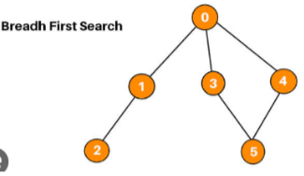

from collections import deque
graph = {
0: [1, 3, 4],
1: [2],
2: [],
3: [5],
4: [5],
5: []
}

def bfs(start_node):
visited = set()
queue = deque([start_node])
print("BFS Traversal:")
while queue:
current = queue.popleft()
if current not in visited:
print(current, end=' ')
visited.add(current)
for neighbor in graph[current]:
if neighbor not in visited:
queue.append(neighbor)
bfs(0)

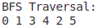

Question 2:
Apply DFS on below grapgh

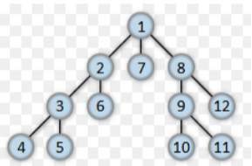

graph = {
1: [2, 7, 8],
2: [3, 6],
3: [4, 5],
4: [],
5: [],
6: [],
7: [],
8: [9, 12],
9: [10, 11],
10: [],
11: [],
12: []
}

def dfs(node, visited=None):
if visited is None:
visited = set()
if node not in visited:
print(node, end=" ")
visited.add(node)
for neighbor in graph[node]:
dfs(neighbor, visited)

print("\nDFS Traversal: ")
dfs(1)

